1. Splash Screen
2. Introduction Pages
   1. Submit Reimbursement Claim
   2. Virtual Card
   3. Tele consultation
   4. Live Chat
3. Settings Page
   * 1. Select Language
     2. Allow Push Notification
4. Tab bar option features – Home, Settings, SignOut

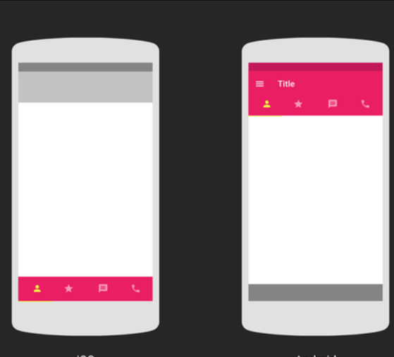

1. Right bottom Corner Button for customer support– Call , Chat , contact
2. Location arrow confusing members. Need to Change
3. Chat Option
4. Reimbursement Flow change
   1. Select Type option – Submission/Resubmission
   2. If resubmission, show ClaimRef option(mandatory)
   3. Select button to pick claim from the list or list last 10 reimbursement claims in the claimRef list

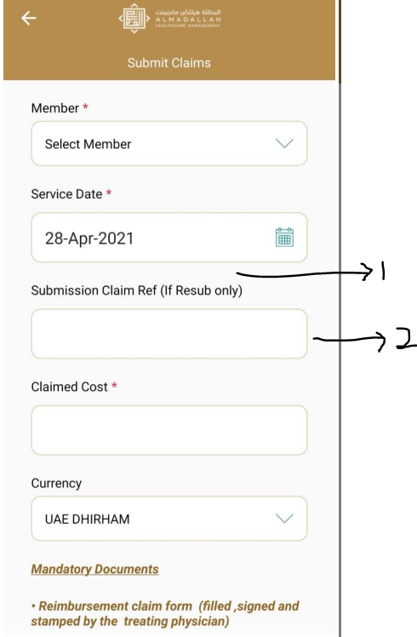

1. Push Notification
2. Dashboard Additions
   1. Download
   2. Request
3. Trudoc Integration